WooCommerce Multi-Currency Plugin for PayUBiz

for WooCommerce 5.5.2

Caution: Always keep backup of your existing WooCommerce installation including Mysql Database, before installing a new module.

Note: WooCommerce does not have built-in multi-currency feature. Hence it is important to use separate multi-currency plugin for WooCommerce. This plugin uses currency present in Order.

Install via WordPress plugin Installer:-

1. Login to WordPress Admin panel and goto Add New Plugin. Then click on Upload Plugin.

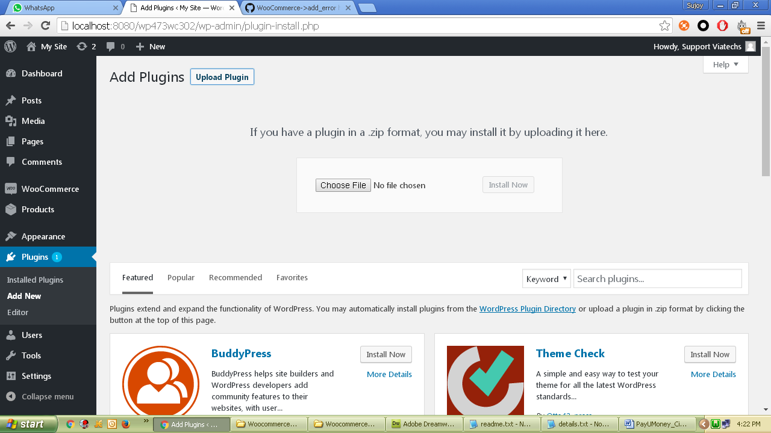

1. Choose this downloaded zip and click Install Now.

Manual Installation:-

1. Unzip and copy ‘WooCommerce_v552_MultiCurrency_PayUBiz’ folder from this zip and paste/upload it to <wordpress root>\wp-content\plugins folder.
2. Login to WooCommerce admin and goto Plugins. Activate the plugin.

Configure Module:-

1. Login to WordPress admin and open WooCommerce Settings.

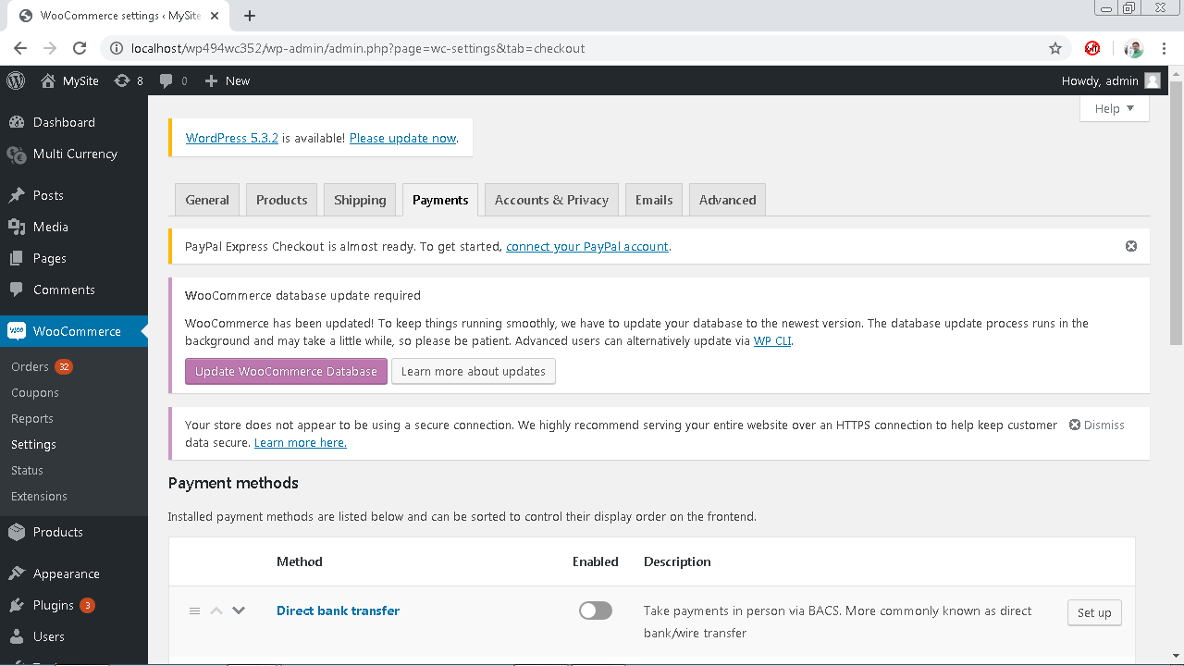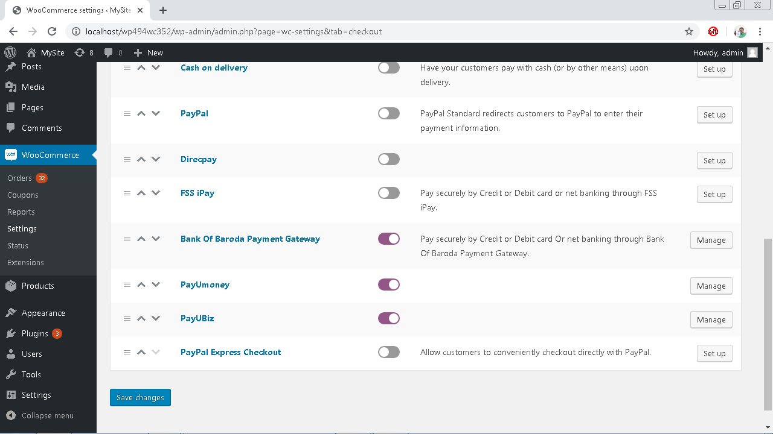

1. Click on Checkout tab and then Setup/Manage on ‘PayUBiz’ plugin.

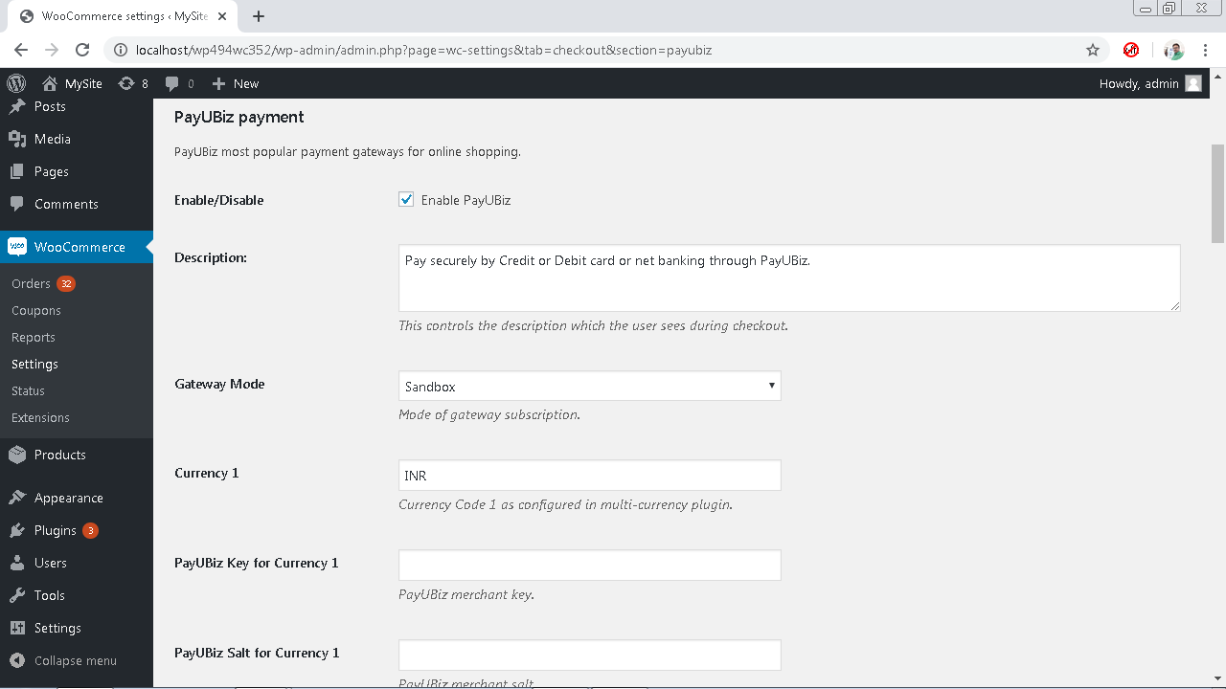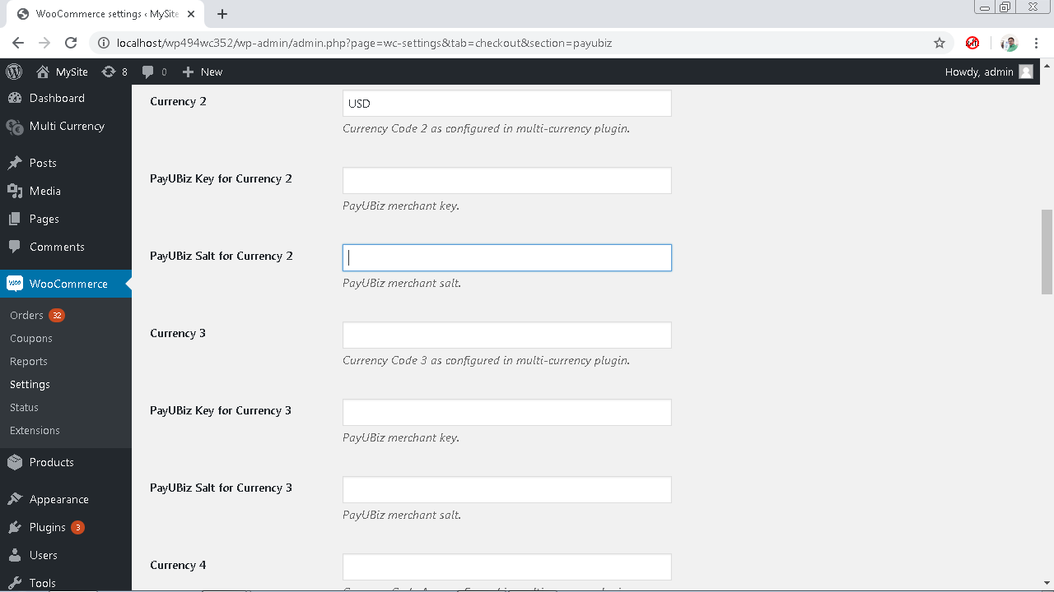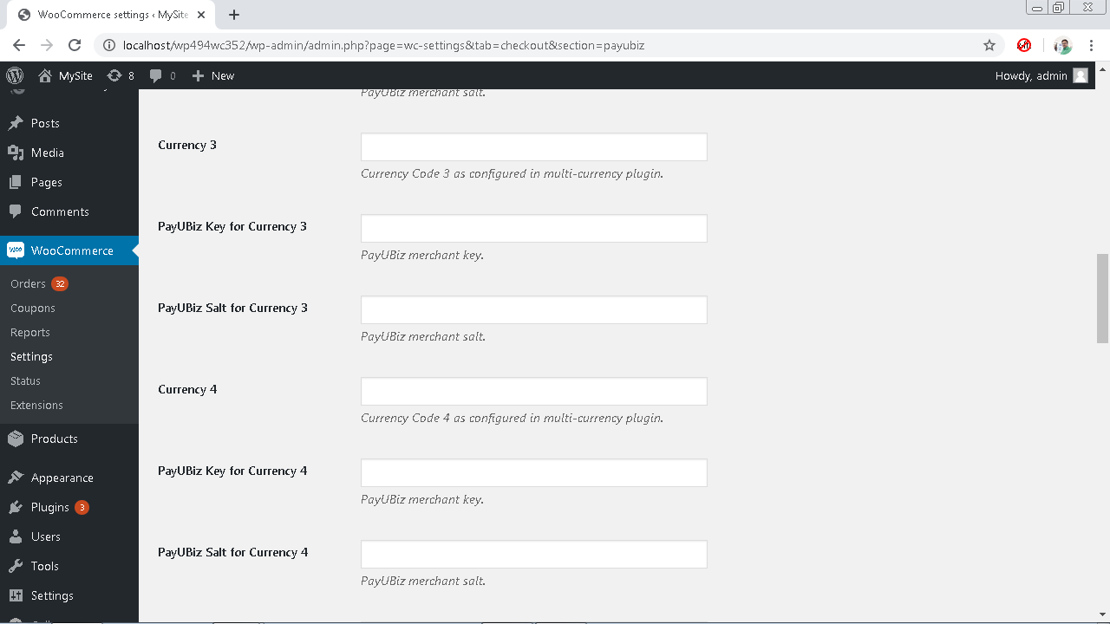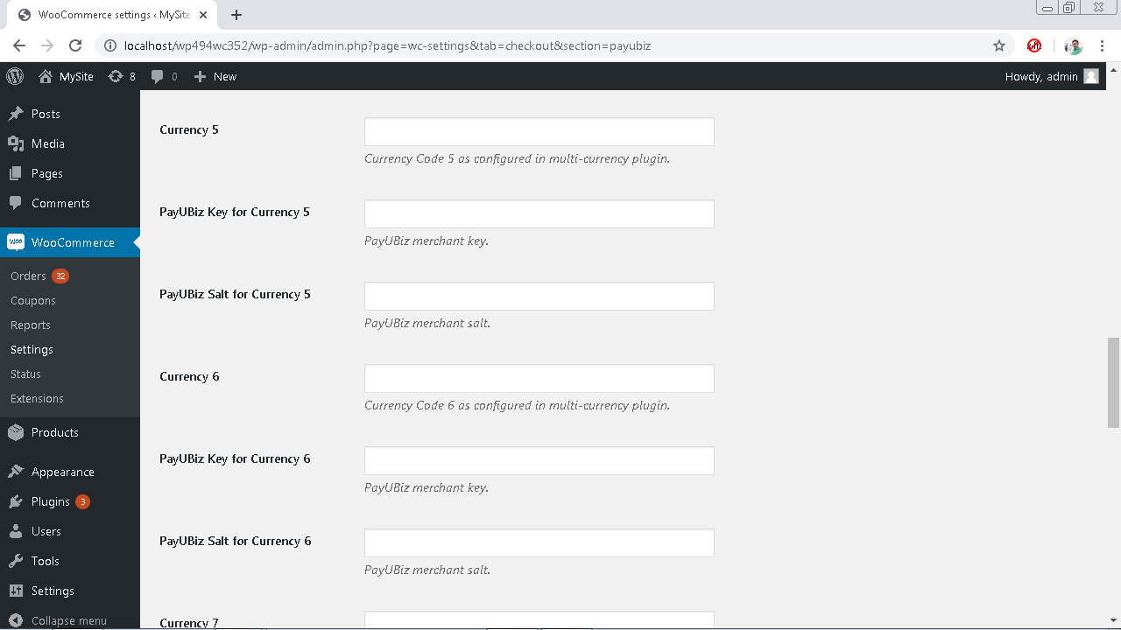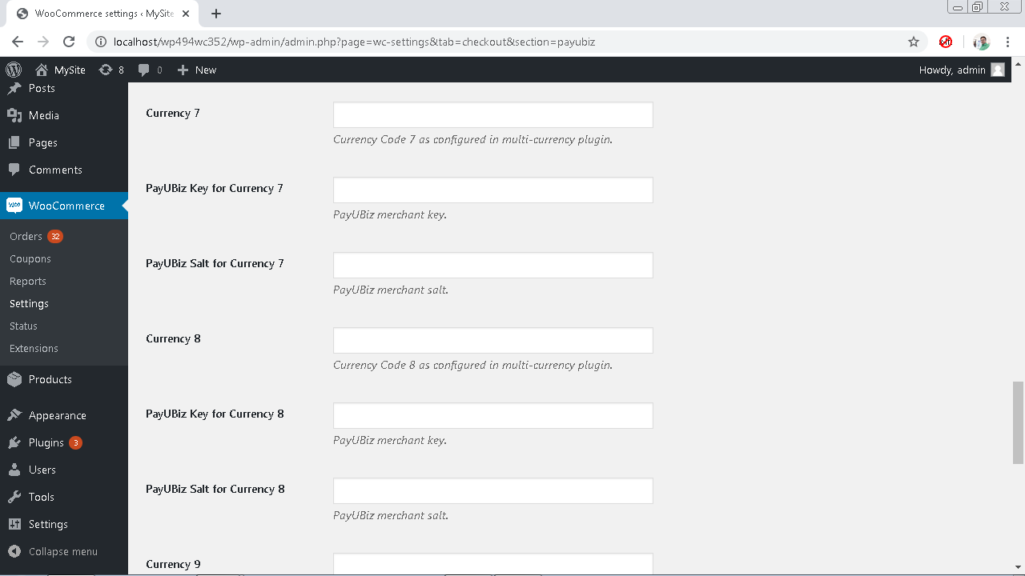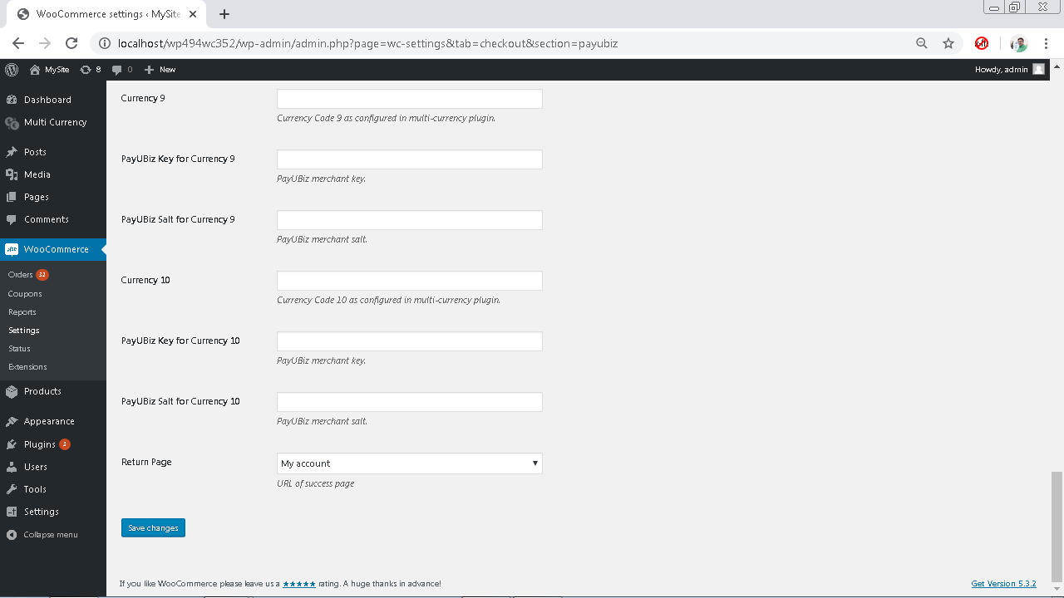

* + Enable/Disable – Tick to enable the module.
  + Description – Enter appropriate description to display at checkout.
  + Gateway Mode - “Sandbox” for sandbox/test operation and “Production” for live operation.
  + Currency, PayUBiz Key and Salt – Here is a set of 10 parameters corresponding to each currency as configured in multi-currency. Configure as many currencies upto a 10 max. E.g. Currency 1- INR, Key – for INR and Salt – for INR
  + Return Page – Use My Account as the default return page after payment response. You may create a custom page and select here. However, the custom page must contain appropriate WordPress / WooCommerce codes to show custom massages. Refer WordPress / WooCommerce development guide for custom pages.

1. Now click save and customer will get PayUBiz option during checkout process.

